Joke Time!

Here are the kinds of places that are too stupid to exist:

- A restaurant where you’re not allowed to eat or drink.
- A library where you’re not allowed to read.
- An airport where you’re not allowed to fly.
- An arcade where you’re not allowed to play.
- A boxing ring where you’re not allowed to fight.
- A theater where you’re not allowed to watch movies.
- A church where you’re not allowed to pray or get married.
- A pool where you’re not allowed to swim.
- A concert where you’re not allowed to play music.
- A barber shop where you’re not allowed to shave.
- A bedroom where you’re not allowed to sleep.
- A kitchen where you’re not allowed to cook.
- A school where you’re not allowed to teach.
- A Laundromat where you’re not allowed to wash your clothes.
- A parking lot where you’re not allowed to park your vehicle.
- A highway where you’re not allowed to drive.
- A race track where you’re not allowed to run at all.
- A factory where you’re not allowed to operate the machines.
- A gym where it’s forbidden to exercise.
- A lab where it’s forbidden to do experiments.
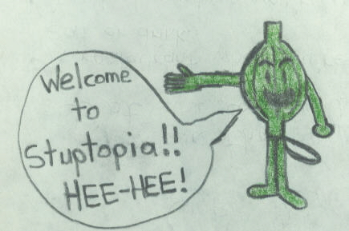

The character in this picture is Onio Vegetable the onion man!
Sally Martin has entered a place called a Laundromat, but this crazy guy won’t let her wash her clothes!

