Good Male Comebacks!
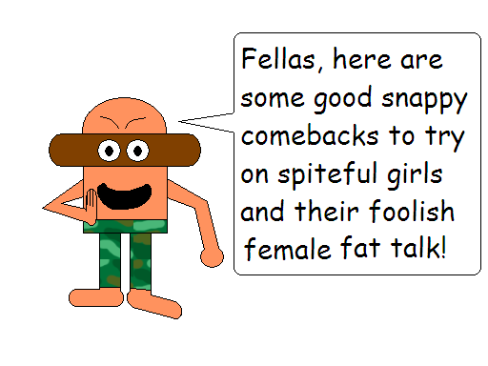
Girl: “Girls rule, boys drool!”
Boy:
- ”Girls rule? Rule what?”
- “Boys drool because girls make them drool!”
- “Oh yeah? Well girls have saliva, too!”

Girl: “If you don’t know why I’m mad at you, then I’m certainly not going to tell you!”
Boy: “Well if you don’t tell me, I’m not going to apologize!”

Girl: “Ladies first!”
Boy:
- “Sorry lady, but I got here first. First come, first serve!”
- “Sorry lady, but this is a race!"

Girl: “Go away!”
Boy:
- “Away from what?”
- “How far away?”
- “Which way?”
- “I am away!”
- “Alright! But first, get off my foot!”

Girl: “Get lost!”
Boy: “I’m already lost!”

Continued on next page
More Male Comebacks:

Girl: “I just need some space.”
Boy: “If you need more space, then why don’t you become an astronaut?”

Girl: “I’ll go out with you when pigs fly!”
Boy: “Pigs can already fly! Just put them in…”
- “…an airplane!”
- “…a helicopter!”
- “…a blimp!”
- “…a hot air balloon!”
- “…a rocket!”
- “If they start flying today, then will you go out with me?”

Girl: “I wouldn’t marry you if you were the last man on Earth!”
Boy:
- “Well I’m not the last man on Earth.”
- “If I was the last man on Earth, who else could you marry?”
- “Well, I wouldn’t marry you unless you were the last woman on Earth!”
- “Okay then, let’s go to Mars!”
- “And cause the extinction of humans?”
