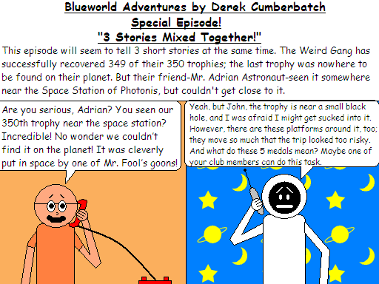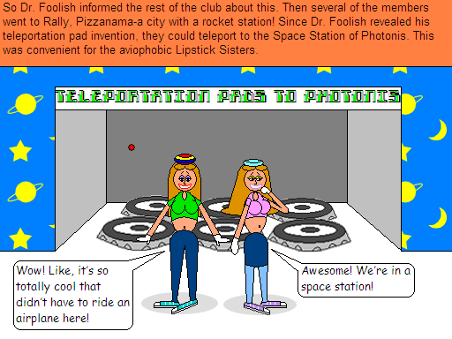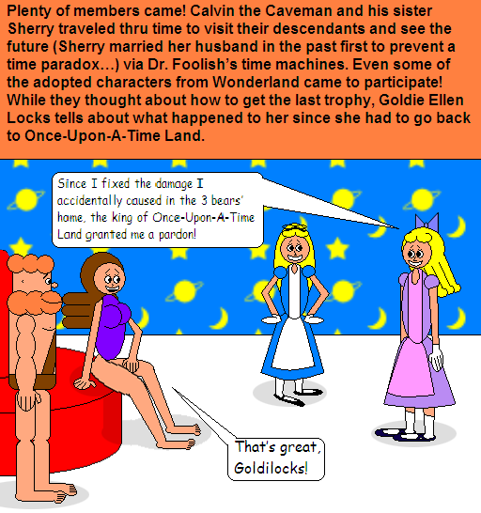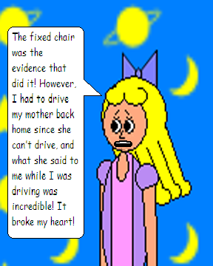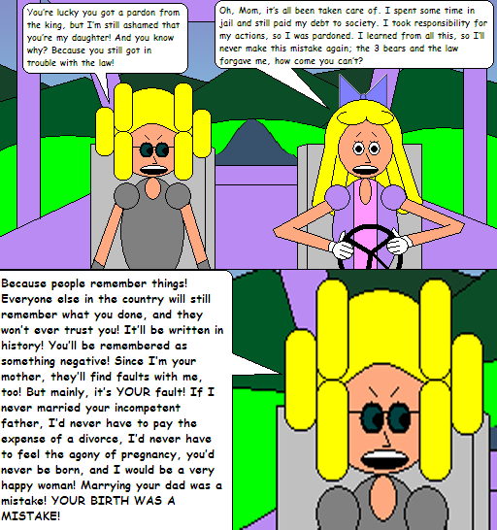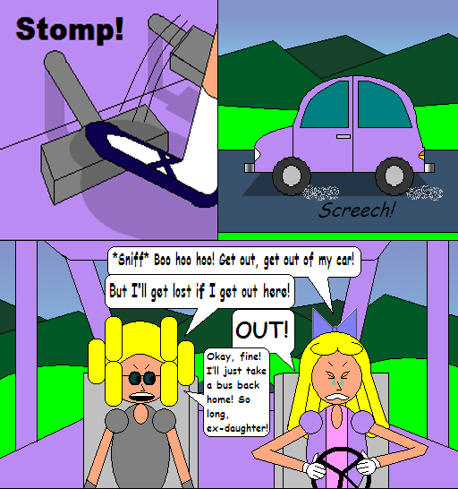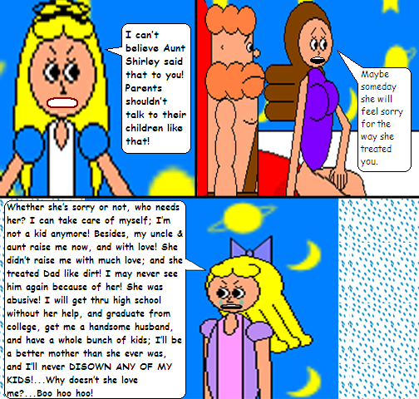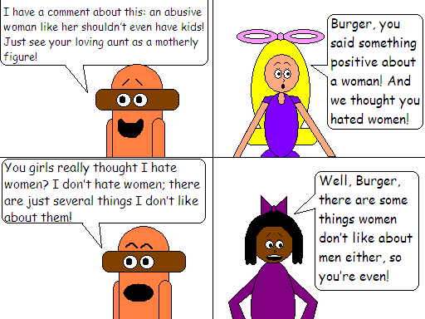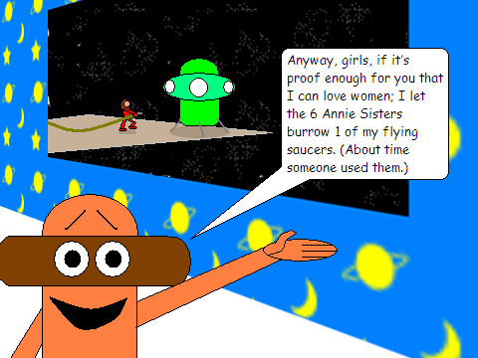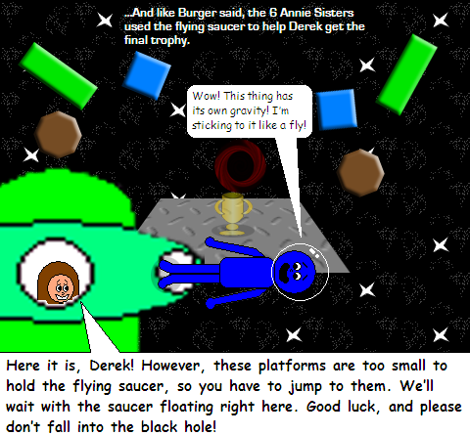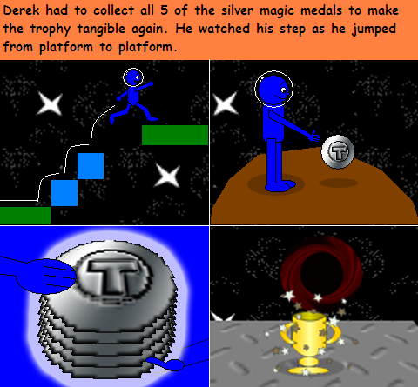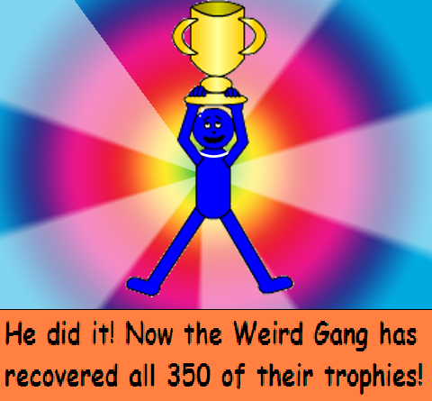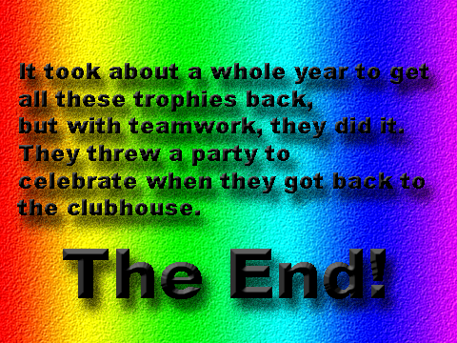

The 3 short stories were:
- Goldilocks’ Not-So-Loving Mother
- Burger Is Not Misogynistic After All!
- The Last Trophy

By the way, this is the final episode…
…Of the first chronicle!
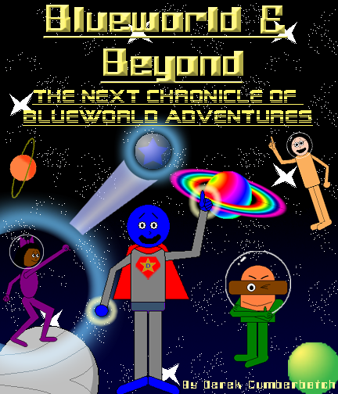
Since the Hamburger Heavy Metallers & Brass Ladies formed a truce, the genie of the 7 Mystical Candles was freed, and the Weird Gang recovered all their 350 trophies, it’s time for this series to have a new chronicle. The Photonese (people of the planet Photonis) gets more in touch with alien worlds, so the characters will have adventures of cosmic proportions! This chronicle will be based on planets, planetoids, stars, comets, galaxies, and other things found in outer space! The stories are going intergalactic! Season 8 begins the next chronicle; the next brand new episode begins Season 8! It’s a treat for sci-fi lovers everywhere!

